Karnatak Law Society’s
GOGTE INSTITUTE OF TECHNOLOGY

Udyambag Belagavi -590008 Karnataka, India.



A Project Report on
COMPILER DESIGN
for
“DESIGN AND IMPLEMENT LL(1) PARSER ”
Submitted by

NAME | USN | SIGN
1) NIKITA TOTIGER | 2GI22CS092
2) PRACHI CHIKADE | 2GI22CS101
3) RUTVI RANE | 2GI22CS117
4) NIDHI D. KALLATTI | 2GI22CS089

Dr. M. M. Math
Assistant Professor
Dr. Sanvjeev S. Sannakki
HoD, of CSE Dept

Academic Year 2024-2025 (Odd semester)
Karnatak Law Society’s
GOGTE INSTITUTE OF TECHNOLOGY

Udyambag Belagavi -590008 Karnataka, India.

Department of Computer Science and Engineering

Certificate
This is to certify that the Project work titled “DESIGN AND IMPLEMENT OF LL(1) PARSER” carried out by NIKITA TOTIGAR, PRACHI CHIKADE, RUTVI RANE, NIDHI D. KALLATTI bearing USNs: 2GI22CS092, 2GI22CS101, 2GI22CS117 and 2GI22CS089 for DESIGN AND IMPLEMENT LL(1) PARSER is submitted in partial fulfilment of the requirements for Complier Design in COMPUTER SCIENCE AND ENGINEERING, Visvesvaraya Technological University, Belagavi. It is certified that all corrections/ suggestions indicated have been incorporated in the report. The project report has been approved as it satisfies the academic requirements prescribed for the Complier Design.

Date: 03/07/2025 Signature of Guide

ACKNOWLEDGEMENTS

We would like to express our sincere gratitude to all those who supported and guided us
throughout the successful completion of our Complier Design, conducted
over the whole semester
First and foremost, we extend our heartfelt thanks to our Principal, M.S.Patil Sir for
providing us with this valuable learning opportunity and for facilitating an environment
conducive to innovation and hands-on learning.
We are deeply grateful to our Head of the Department, Rajeev Sannakki Sir Department of
Computer Science and Engineering, for their continuous encouragement and support
throughout this course.
We would like to acknowledge the guidance and mentorship provided by our Complier Design
Guide, Dr. M.M Math sir, whose expertise and timely feedback, played a crucial role in the successful execution of our project.
Our sincere thanks to the teaching and non-teaching faculty of the Department of Computer
Science and Engineering for their assistance, resources, and encouragement during the lab
sessions.
We are also thankful to our friends for their collaboration, teamwork, and helpful discussions
that enriched our learning experience.
Lastly, we would like to express our deepest appreciation to our families for their unwavering
support, motivation, and patience throughout this journey.

ABSTRACT:
This project implements an LL(1) parser for a given context-free grammar, which is a vital component in the syntax analysis phase of compiler design. LL(1) parsers are top-down parsers that read the input from Left to right and produce a Leftmost derivation using 1 lookahead symbol. However, most grammars used in practice are not directly suitable for LL(1) parsing due to the presence of left recursion and common prefixes in productions.
To address this, the parser begins by transforming the grammar through the elimination of left recursion, ensuring that infinite recursive loops are avoided. Next, it performs left factoring to eliminate ambiguity when the parser faces multiple productions starting with the same prefix.
Once the grammar is in an appropriate form, the parser proceeds to compute the FIRST and FOLLOW sets for all non-terminal symbols. These sets are essential for the construction of the LL(1) parsing table, which maps non-terminals and input symbols to their corresponding production rules.
The parser then uses a stack-based approach to simulate the parsing of input strings according to the constructed table. It matches terminals and non-terminals as per the predictive logic, clearly indicating every step of the parsing process. This not only helps in determining whether a string belongs to the language generated by the grammar but also provides valuable insight into how LL(1) parsers operate.
Overall, this project provides a complete and interactive implementation of LL(1) parsing and reinforces core compiler design concepts like grammar normalization, syntax analysis, and table-driven parsing.

TABLE OF CONTENT:

S.No | Title | Page No.
1 | Acknowledgment | 3
2 | Abstract | 4
3 | Introduction | 6
4 | Objectives | 7
5 | Algorithm used | 7-8
6 | Tools used | 8
9 | Snippets of Code | 8-9
10 | Output | 10
11 | PPT Screen shots | 11-13
11 | Conclusion | 14
12 | References | 14

LL(1) Parser for Context-Free Grammar

INTRODUCTION
LL(1) parsing is a fundamental technique in the field of compiler design, particularly within the syntax analysis phase of compilation. It belongs to the class of top-down parsers that read input from Left to right and produce a Leftmost derivation using 1 lookahead symbol, hence the name LL(1). This method of parsing is deterministic, meaning that for any given input and parser state, only one parsing decision is made — which makes it efficient and straightforward to implement.
However, not all context-free grammars are directly suitable for LL(1) parsing. Many grammars exhibit properties such as left recursion or common prefixes among productions, which can lead to ambiguity or non-determinism. These characteristics must be addressed to make the grammar LL(1)-compatible.
- This project begins by transforming the original grammar into a form that adheres to LL(1) constraints. This involves:
- Removing left recursion, which otherwise causes infinite loops in top-down parsers.
- Applying left factoring, which eliminates ambiguity when multiple productions for a non-terminal begin with the same symbol.
- Once the grammar is in LL(1) form, the next step is to calculate the FIRST and FOLLOW sets for each non-terminal:
- The FIRST set helps determine which terminal symbol may begin strings derived from a non-terminal.
- The FOLLOW set indicates which symbols may appear immediately after a non-terminal in any derivation.
These sets are then used to construct the LL(1) parsing table, a core data structure in predictive parsers. The table maps a non-terminal and an input terminal to the appropriate production rule to apply. This table-driven parsing mechanism simplifies the parser implementation and improves its clarity and speed.
Using this parsing table, the project simulates string parsing with a stack-based predictive parser. The parser reads the input string character by character and uses the parsing table to determine whether the string can be derived from the grammar. It reports the step-by-step action taken (matching symbols, applying productions) and validates whether the input string belongs to the grammar’s language.
By completing this project, students not only learn how to implement a working LL(1) parser but also gain deep insights into how syntax analyzers function internally in modern compilers. The practical exposure to grammar transformation, parsing logic, and debugging invalid inputs prepares them for more advanced topics such as error recovery, abstract syntax trees, and intermediate code generation.

OBJECTIVES
- Understand and implement grammar transformation techniques.
- Compute FIRST and FOLLOW sets.
- Construct LL(1) parsing table.
- Parse input strings using the table.
- Validate string acceptance through parser logic.

ALGORITHM USED
Algorithm Steps:
- Initialize Stack:
- Create a parsing stack and push $ (end marker) and S (start symbol) onto the stack.
- Append End Marker to Input:
- Append $ to the end of the input_string.
- Start Parsing Loop:
- Repeat the following steps until the stack is empty
- Check Top of Stack:
- Let top be the symbol at the top of the stack.
- Let current_input be the current symbol pointed to in the input_string.
- Case 1: Match:
- If top == current_input:
- Pop top from the stack.
- Advance the input pointer.
- Case 2: Epsilon:
- If top == "ε":
- Pop the epsilon from the stack (skip it).

- Case 3: Non-terminal:
- If top is a non-terminal (i.e., in the parse_table):
- Look up parse_table[top][current_input] to find a rule.
- If a rule is found:
- Pop top from the stack.
- Push the right-hand side of the rule in reverse order onto the stack (unless it's epsilon).
If no rule is found:
- Report a syntax error and exit.
- Case 4: Mismatch:
- If top is a terminal but not equal to current_inpu
- Report a mismatch error and exit.
- End of Loop:
- Continue until the stack is empty.
- Final Check:
- If the input pointer has consumed the entire input string (pointer == len(input_string)):
- Report successful parsing.
Else:
- Report error: input not fully consumed.

TOOLS USED
- Python 3
- VS Code
- CMD Terminal
- Regular Expressions Library

- SNIPPETS OF THE CODE

- Design and implement LL(1) Parser for the following grammar. Demonstrate the working with valid and invalid inputs
S → aB | ac | Sd |Se
B →bBc | f
C → g

parse_table = {
"S": {
"a": ["a", "B"],
"d": ["S'"],
"e": ["S'"]
},
"S'": {
"d": ["d", "S'"],
"e": ["e", "S'"],
"$": ["ε"]
},
"B": {
"f": ["f", "B'"]
},
"B'": {
"b": ["b", "B'", "c"],
"d": ["ε"],
"e": ["ε"],
"$": ["ε"],
"c": ["ε"]
},
"C": {
"g": ["g"]
}
}

def parse(input_string):
stack = ["$", "S"]
input_string += "$"
pointer = 0
print("\nParsing Steps:")
step = 1
while stack:
top = stack[-1]
current_input = input_string[pointer]
print(f"{step:02d}: Stack: {stack} | Input: {input_string[pointer:]}")
if top == current_input:
stack.pop()
pointer += 1
elif top == "ε":
stack.pop()
elif top in parse_table:
rule = parse_table[top].get(current_input)
if rule:
stack.pop()
if rule != ["ε"]:
stack.extend(reversed(rule))
else:
print(f"❌ Error: No rule for {top} with input '{current_input}'")
return
else:
print(f"❌ Error: Mismatch at top '{top}' and input '{current_input}'")
return
step += 1

if pointer == len(input_string):
print("✅ Input string parsed successfully!\n")
else:
print("❌ Error: Input string not fully consumed.\n")

print("LL(1) Parser Initialized:")
print("Grammar:")
print("S → aB | ac | S'")
print("S' → dS' | eS' | ε")
print("B → fB'")
print("B' → bB'c | ε")
print("C → g")
print("\nType 'exit' to stop.\n")

while True:
user_input = input("Enter input string to parse: ")
if user_input.lower() == "exit":
print("👋 Exiting parser. Goodbye!")
break
parse(user_input)

- OUTPUT:

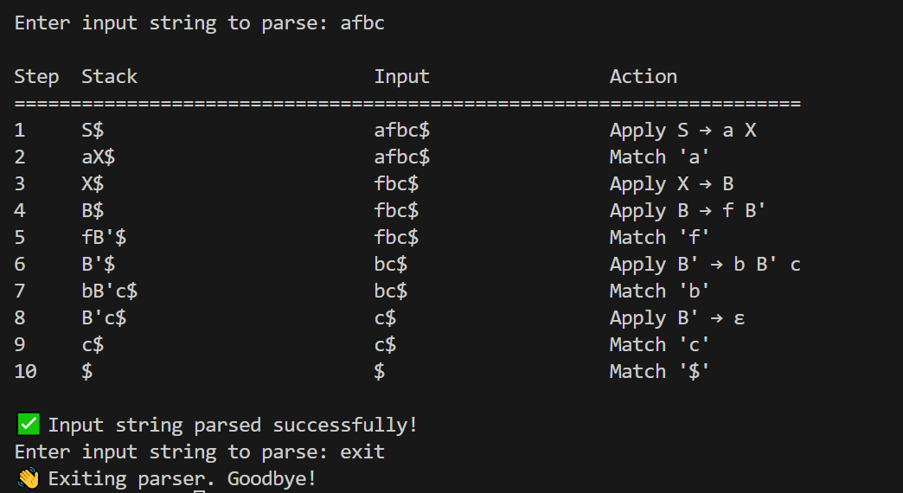

- PPT SCREEN SHOTS


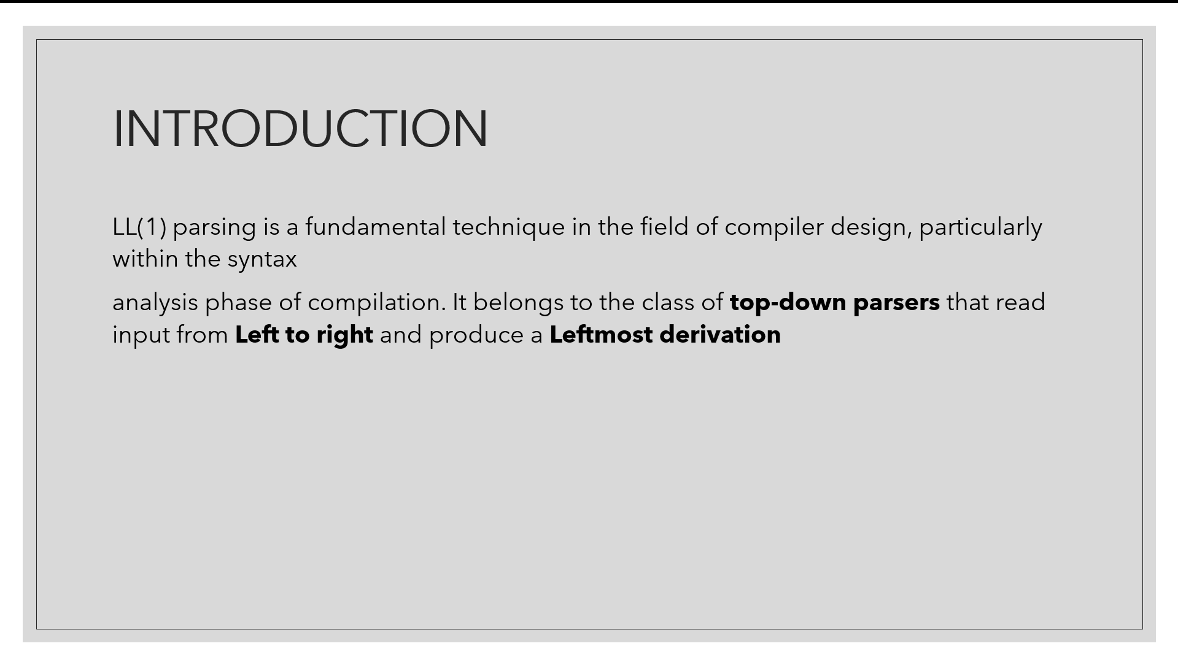

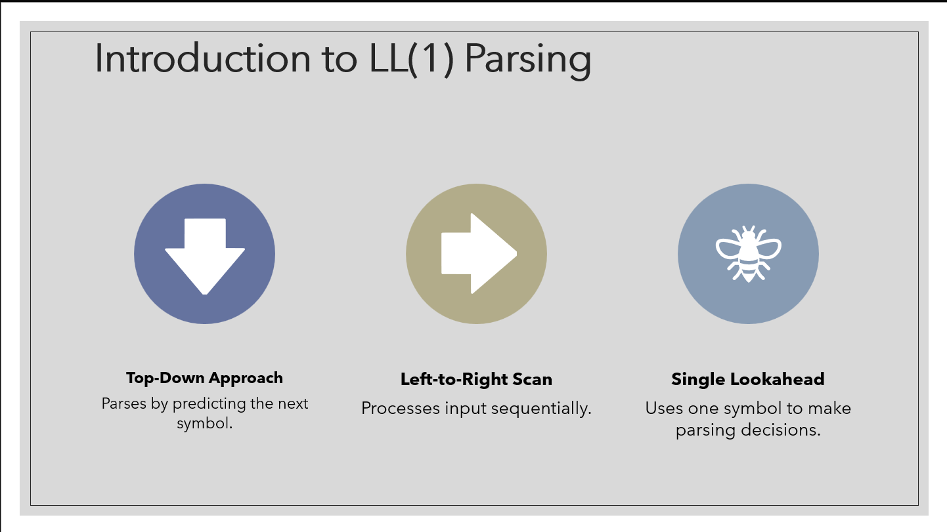

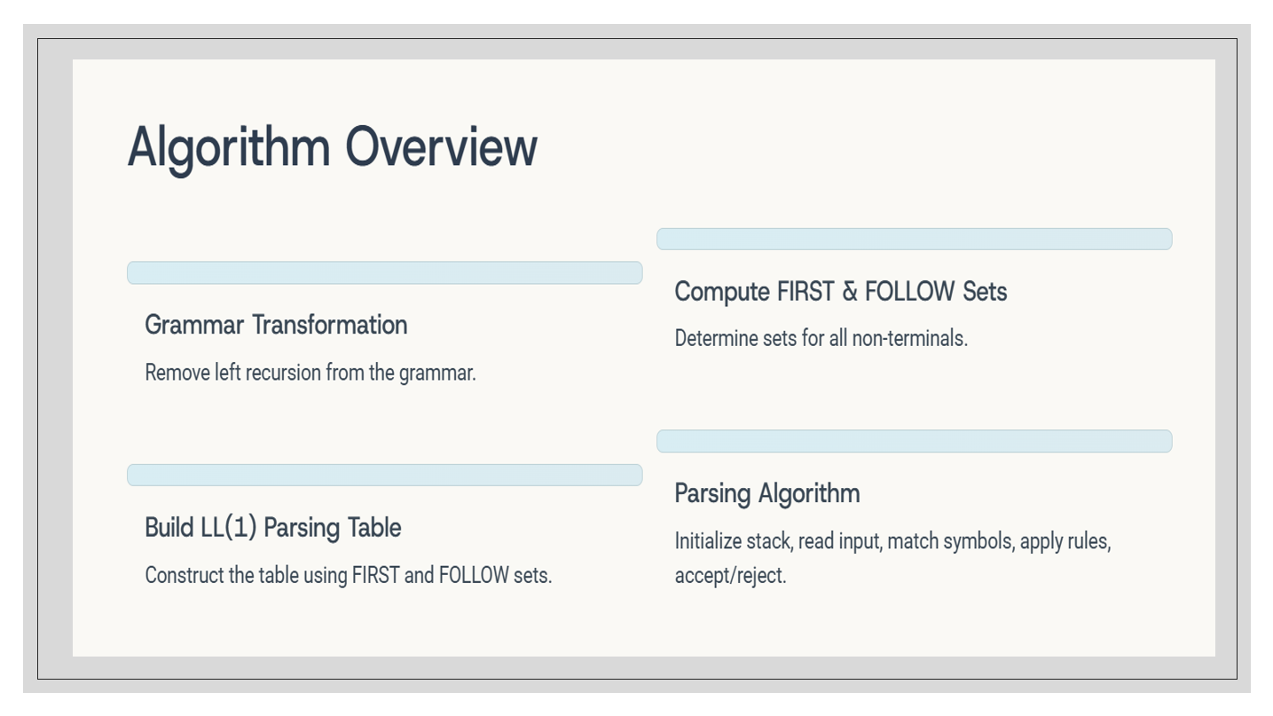

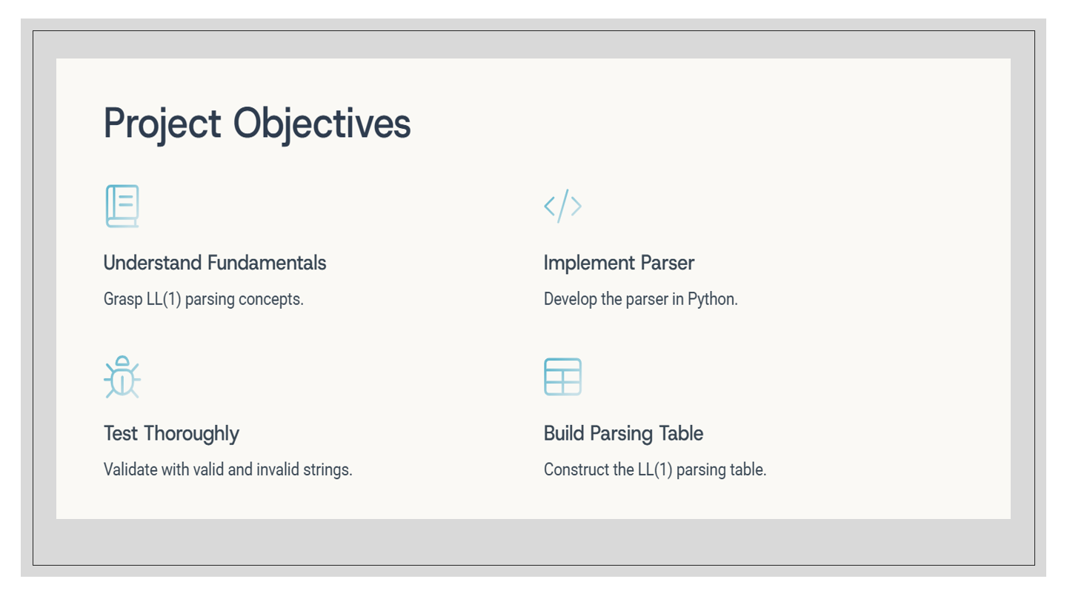

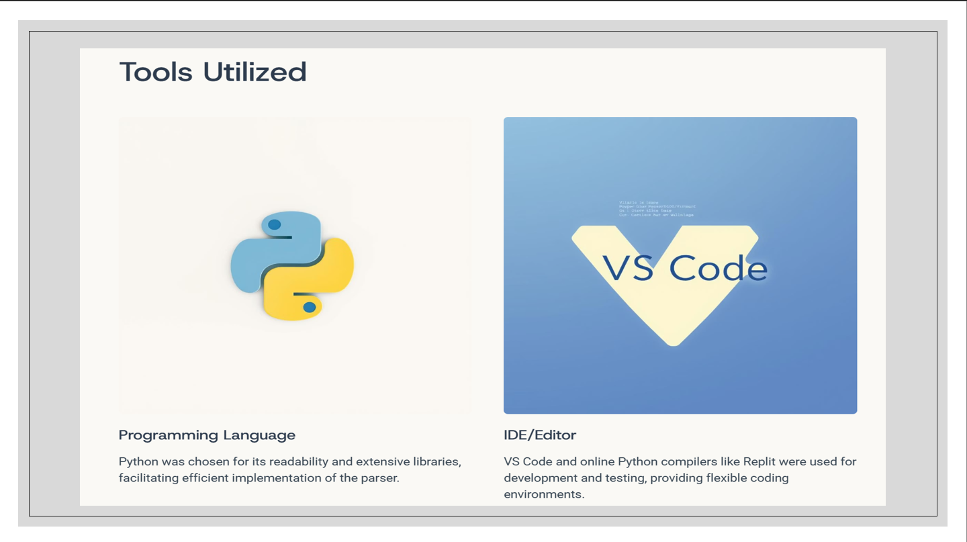

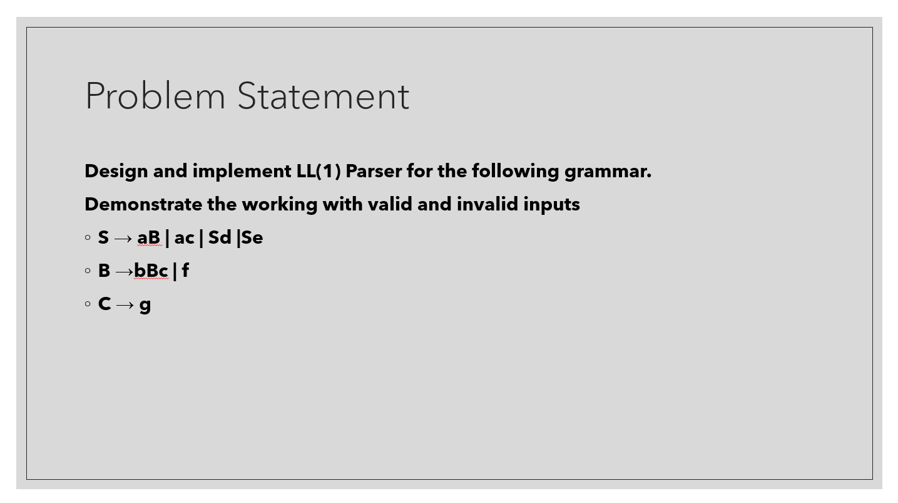

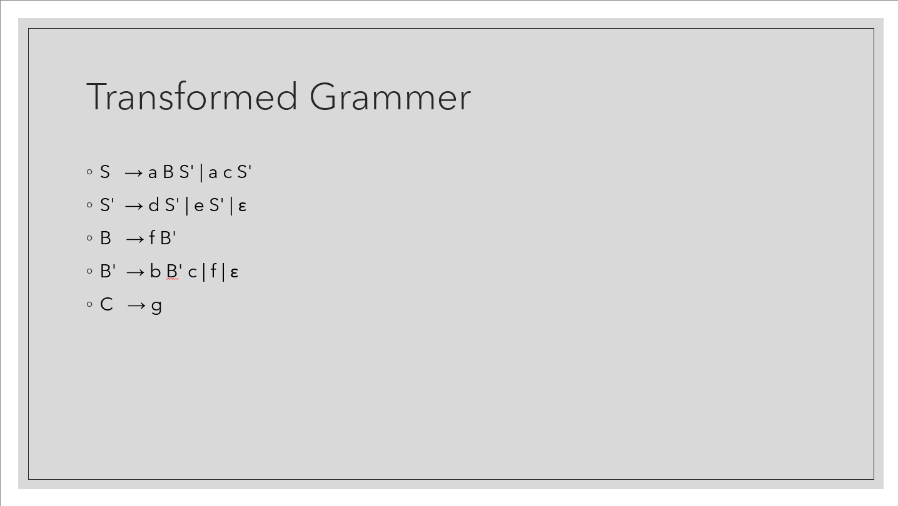

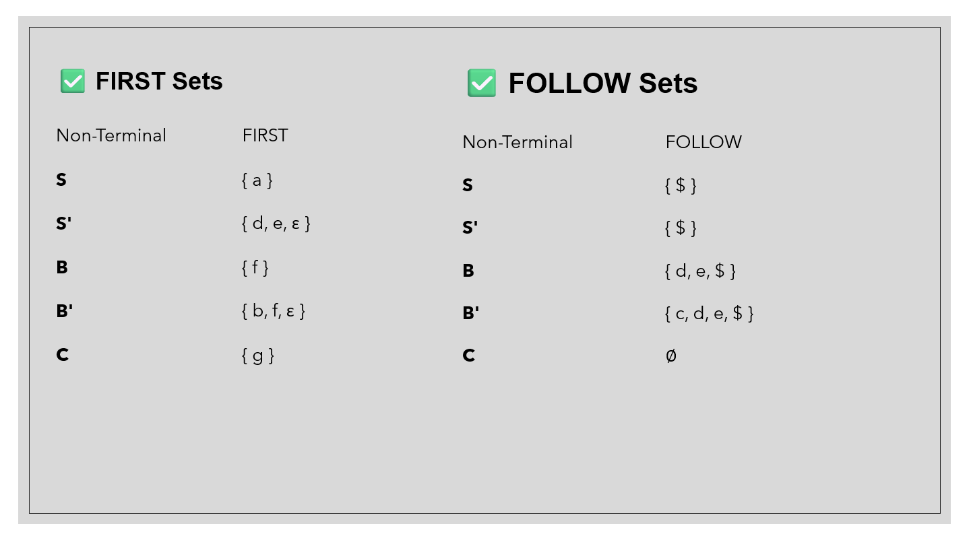

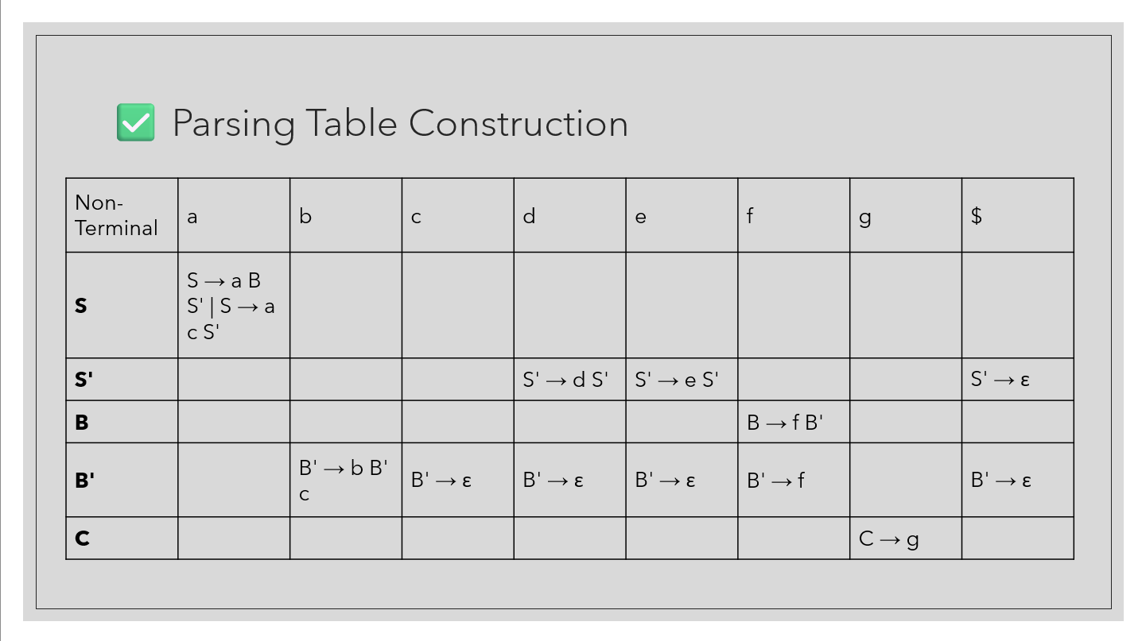

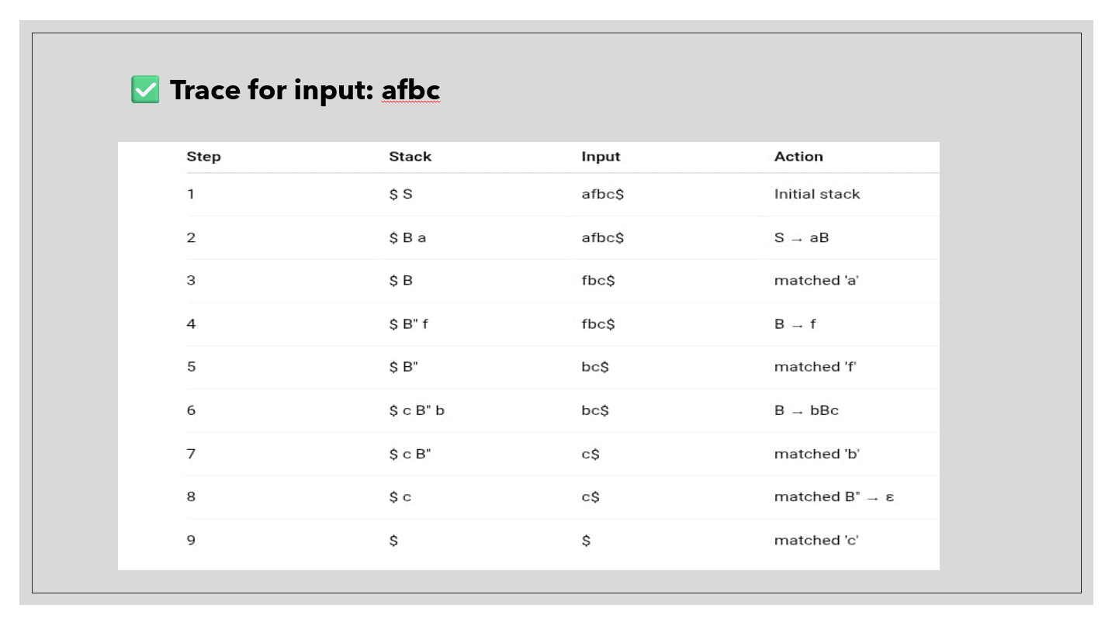

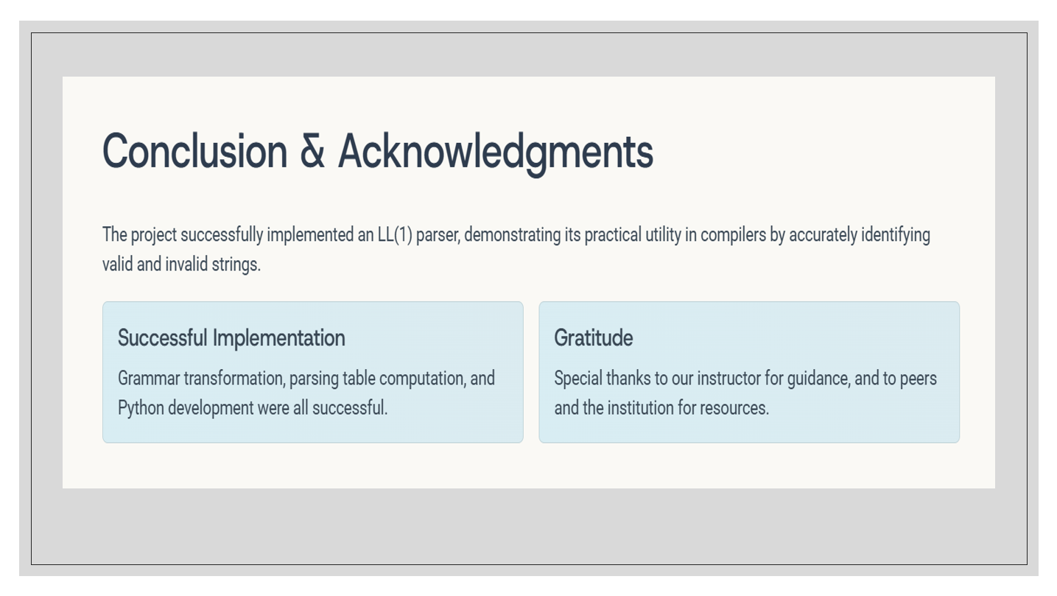

CONCLUSION

This project demonstrates the complete pipeline for implementing an LL(1) parser. By applying grammar transformation techniques such as left recursion removal and left factoring, the grammar is converted into a suitable form for predictive parsing. The calculation of FIRST and FOLLOW sets, followed by the construction of the parsing table, ensures a systematic way to parse input strings. Through this project, we gained practical experience in understanding the working of syntax analyzers used in compilers. The implementation verifies whether a given string can be generated by the grammar using LL(1) parsing, providing immediate feedback for valid and invalid inputs.

REFERENCE
1. Aho, Lam, Sethi, Ullman. *Compilers: Principles, Techniques, and Tools*.
2. Class notes and tutorials from Compiler Design course.
3. Python documentation: Our Documentation | Python.org
4. Online resources and tutorials on LL(1) parsing and predictive parsers.
- YOUTUBE: https://youtu.be/WTxdKQmsfho?si=mEmxiYrjEPBqrXUM
- https://youtu.be/DT-cbznw9aY?si=dnPDA7jJfVRcicAz
- https://youtu.be/en0Mptigzkw?si=U_ZW7TUV7OJXPtEU

